

**MASTER THESIS**

|  |
| --- |
| **TITLE:**  **MASTER DEGREE: Master's degree in Applied Telecommunications and Engineering Management (MASTEAM)**  **AUTHOR: Dimitrios Chatzos**  **ADVISOR: Prof. Vicenç Fernández**  **DATE:** |

|  |
| --- |
| **Title:**  **Author:**  **Advisor:**  **Date:** |

**Abstract**

|  |
| --- |
| The purpose of this paper is to identify and empirically examine the key features, purposes, uses, and benefits of performance dashboards.  Dashboards were used for four distinct purposes: (i) monitoring, (ii) problem solving, (iii) rationalizing, and (iv) communication and consistency.  There was a high correlation between the different uses of dashboards and user productivity indicating that dashboards were perceived as effective tools in performance management, not just for monitoring one's own performance but also for other purposes including communication. The quality of the data in dashboards did not seem to be a concern (except for completeness) but it was a critical driver regarding its use.  The study highlights the designing rules for creating dashboards and taking the foul potential and benefits of dashboards, which could be valuable for future researchers and practitioners for the uses of universities and more specific for UPC.  Furthermore, those fundamentals will be applied to create a Dashboard for the needs of UPC. This will include the most important features and information for the user to observe the behaviour of the different areas of the UPC and to manage any kind of information for the UPC taking important decisions according to the data that will be on the Dashboard. |

**CONTENTS**

INTRODUCTION 6

CHAPTER 1. Dashboard Definition 8

1.1 The guidelines of the dashboard design 9

1.2 The fundamentals of dashboard design 10

1.2.1 Content 10

1.2.1.1 Keep it relevant 10

1.2.1.2 Keep it simple 11

1.2.1.3 Iconography 11

1.2.2 Layout 12

1.2.2.1 Group related data together 12

1.2.2.2 Keep uniform size 12

1.2.2.3 Put limits to your data 13

1.2.3 Colours 14

1.2.3.1 Leverage contrast 14

1.2.3.2 Use colours only for specific reasons 14

1.2.3.3 Pay attention to the meaning of colours 15

1.2.3.4 Test for colour blindness 16

1.2.4 Fonts 16

1.2.4.1 Keep standard your font sizes 16

1.2.4.2 Combining fonts and colours together 17

1.3 Visualization of the Dashboard 18

1.4 Visualisation Techniques 20

1.4.1 Static visualization 20

1.4.2 Interactive visualization 20

1.4.3 Drilldowns vs. Drill-Through 20

1.4.3.1 Drilldowns 20

1.4.3.2 Drill-through 20

1.4.3.3 Zooming 20

1.5 Validation of the Dashboard 21

1.5.1 Build a Wireframe 21

1.5.2 Build prototypes 22

1.5.3 Regularly tests and upgrades 23

1.6 Future work of Dashboard Design 23

CHAPTER 2. Analysis of the case MASTEAM 25

2.1 Creation of Interview questions 25

2.2 Interview part 27

CHAPTER 3. Design a Dashboard 29

3.1 Creation of the datasets on CSV format 29

3.1.1 Enrolment CSV dataset 29

3.1.2 Students information CSV dataset 30

3.1.3 Students grades CSV dataset 31

3.1.4 Courses and Grades CSV dataset 31

3.1.5 Number of students per course CSV dataset 32

3.2 Build the dataset Wireframe 32

3.2.1 Main page Wireframe 32

3.2.2 Students page Wireframe 33

3.3.3 Courses page Wireframe 33

CHAPTER 4. Implementation of the Dashboard 34

4.1 Implementation of the main Dashboard page 34

4.2 Implementation of the Students page 36

4.2.1 Students Info subpage 37

4.2.2 Students Grades subpage 38

4.3.3 Students Summary subpage 39

4.3 Implementation of the Subject page 39

4.3.1 Subjects subpage 40

4.3.2 Summary of Subjects subpage 41

4.3.3 Number of Students per Subject subpage 41

CHAPTER 5. Rcode and Maintenance of the Dashboard 43

5.1 R code explanation 43

5.1.1 Libraries explanations 44

5.1.2 Datasets edit and maintenance 45

5.2 Maintenance of the Dashboard 46

CONCLUSION 48

**LIST OF FIGURES**

**Fig. 1.1** Iconography -icons- 13

**Fig. 1.2** Layout -Wrong & Correct- 14

**Fig. 1.3** Data limits 15

**Fig. 1.4** Colour combination 16

**Fig. 1.5** Colour combination 17

**Fig. 1.6** Colour-blind Dashboard 18

**Fig. 1.7** Font size 18

**Fig. 1.8** Combination of fonts and backgrounds colours 19

**Fig. 1.9** Heat maps 21

**Fig. 1.10** Example of Dashboard Wireframe 24

**Fig. 1.11** Dashboard prototype 24

**Fig. 3.1** Enrolment dataset 32

**Fig. 3.2** Students personal info 32

**Fig. 3.3** Students Grades 33

**Fig. 3.4** Courses Grades and enrolled student 33

**Fig. 3.5** Number of student per course 34

**Fig. 4.2** Main Dashboard page 36

**Fig. 4.3** Main Dashboard page –Upper part- 37

**Fig. 4.4** Main Dashboard page -Bottom part- 38

**Fig. 4.5** Main Dashboard page -bottom part/Years- 38

**Fig. 4.6** Students page –Students Info- 39

**Fig. 4.7** Students page -Search box- 40

**Fig. 4.8** Students page –Grades- 40

**Fig. 4.9** Students page - Summary- 41

**Fig. 4.10** Subject page –Subjects- 42

**Fig. 4.11** Subject page -Summary of Subjects- 43

**Fig. 4.12** Subject page -Number of Student per Subject- 44

**Fig. 4.13** Number of Student per Subject -Slider Box- 44

**Fig. 5.1** Edit datasets -library (editData)- 48

**Fig. 5.2** Edit datasets -command (editable = True)- 48

# INTRODUCTION

The Universitat Politècnica de Catalunya (UPC) is among the greatest universities in the world and one of the best in Spain. UPC is among the 125 best in the world in Computer Science and among the 200 best in Engineering and Technology. UPC is also in Telecommunications, Electrical and Electronic Engineering 47th globally and 1st in Spain according to the “[National Taiwan University Ranking by subject National Taiwan University Ranking by subject” and to the](https://www.upc.edu/ranquings/en/upc-at-international-rankings/rankings/national-taiwan-university-ranking-performance-ranking-of-scientific-papers) “[Shanghai Ranking's Global Ranking of Academic Subjects”.](https://www.upc.edu/ranquings/en/upc-at-international-rankings/rankings/shanghairankings-global-ranking-of-academic-subjects)

UPC at this time has 30.864 students and 3.006 teaching and recharging staff, 21 schools, 70 bachelor degrees, 73 Master degree, 48 doctoral programs and over than 280 million euros budget on 2018.

UPC has several schools in Barcelona and in towns that are near like Castelldefels, Manresa, Sant Cugat de valles, Terrasa and Vilaniva i la Geltrú. UPC has also affiliated schools in Barcelona, Terrassa and Igualada. All these schools have high education system and high reputation and history in the world.

The UPC is an International Campus of Excellence with two projects, the Barcelona Knowledge Campus (BKC) and the Energy Campus. Through these projects, it promotes employability, social cohesion and regional economic development. It interacts with research centres, science and technology parks, businesses and other agents as a hub for attracting talent in emerging research areas. In addition, through its four UNESCO Chairs, the UPC contributes to the exchange of knowledge and fosters cooperation.

For this Thesis as a Master Student of “Master's degree in Applied Telecommunications and Engineering Management (MASTEAM)”, I will be focused on the Castelldefels School of Telecommunications and Aerospace Engineering (EETAC) creating a Dashboard for the needs of the MASTEAM master department.

The School of Telecommunications and Aerospace Engineering (EETAC) is a technical school of higher education system of UPC and Barcelona TECH. EETAC has a various fields of education programs of Bachelor's degrees, Master's degrees and several Doctoral programs in the fields of Telecommunications and Aerospace Engineering.

The school is famous for his strong commitment with educational innovation and quality for activities that are related with the industrial environment and with main goal to contribute in the Society making it better in several technological fields.

The academic success of the School is based on:

* Being pioneer in Spain in terms of cooperative project-based learning (PBL), with a small number of students per class.
* Using a continuous assessment system that encourages our students to work regularly during the semester.
* Promoting experimentalism and the use of the laboratories, which are available for students also after lecture hours.
* Giving the opportunity to our students to include internships in their study plan (more than 250 students per year, about 400 hours per student, agreements with more than 180 companies).

Since its inception in 1991, the School is committed to quality teaching and management. A system for the management of the teaching quality (*Sistema Integral de Gestió de Qualitat* - SGIQ) was designed and implemented, after which in 1999 the School was awarded with the ISO 9001:1994 certification issued by the company Det Norske Veritas (DNV), thus being the first public university in Spain to obtain it. This certificate has been renewed and, since 2009, the SGIQ has been restructured and adapted following the guidelines of the AUDIT program.

In 1996, the School was awarded with the most significant award given by the Catalan Government to academic institutions: the "Jaume Vicens Vives" prize for the structure of the degree in Telecommunications. In 2004, the same prize was granted again for the quality and organisation of the degree in Telecommunications Engineering, which followed the model of cooperative and project-based learning (PBL).

The school won the 2005 Flyer, awarded by the National Association of Aerospace Engineers for the structure and quality of the Bachelor's study plan in Aerospace Engineering.

On October 2006, the Agency for the University Quality (AQU) issued to our School the first prize for the "Quality in the Management System of the EETAC, both for its organization and teaching" and the second prize for the "adaptation of the study plan to the European Higher Education Area".

# Dashboard Definition

The majority of the people had already use a reporting software and question is why and for what is the need of a Dashboard at all. Many user can say that dashboards are just another way of presenting the information that is in reports. The truth is that the Dashboards **are not reports** and the contain abilities that neve can see in a normal reporting software.

The majority of reports until now are static without any interaction with the end user. Reports may provide useful information, but on their own, they show only one piece of the puzzle. What is more, many users (especially managers and executives) lack the time to decipher what a report or chart means. Reports do not allow these users to add more pieces of information, dig in to real-time data, or change how information displayed are. Furthermore, reports only include pre-determined datasets.

Dashboards are analytics tools that give users a unified view of the most important data. They consolidate real-time information in a simple, easy-to-understand, and dynamic format. Dashboards are especially useful when you are considering or comparing multiple datasets at time.

Dashboards can be separated according to role and are either **strategic**, **analytical**, **operational**, or **informational**.

Strategic dashboardssupport managers at any level in an organization, and provide the quick overview that decision makers need to monitor the health and opportunities of the business. Dashboards of this type focus on high-level measures of performance, and forecasts. Strategic dashboards benefit from static snapshots of data (daily, weekly, monthly, and quarterly) that are not constantly changing from one moment to the next.

Dashboards for analytical purposesoften include more context, comparisons, and history, along with subtler performance evaluators. Analytical dashboards typically support interactions with the data, such as drilling down into the underlying details.

Dashboards for monitoring operations are often been designed differently from those that support strategic decision-making or data analysis and often require monitoring of activities and events that are constantly changing and might require attention and response at a moment's notice.

However, a dashboard is only as effective as its design and that design should be dictated by the needs of the users. That is why defining the audience is an essential first step in Dashboard design.

Recognize the different use cases in each department as well as the distinct needs of different users across the different organization. Nearly every analytic user will be into one of three categories or personas that are mentioned below:

* **Information consumers:** The majority of analytics users fall in this category. These users prefer to work with a predefined dashboard experience where they can regularly view, interact with, and personalize a preconfigured asset.
* **Content creators:** A creator’s self-service experience is more managed than predefined. These users want the ability to choose the data they need and supplement those existing dashboards and reports with their own metrics.
* **Data analysts:** An analyst’s experience is entirely self-directed. These power users prefer to bring their own data, build their own dashboards and reports, and mine insights they can share with others.

Once is decided what kind of dashboard it will be created according to his role (**strategic**, **analytical**, **operational**, or **informational**) and the users are placed into the three buckets above, the next step is to arrange interviews with each group of users about their requirements.

## 1.1 The guidelines of the dashboard design

After analysing the meaning of the Dashboards, define the audience and the purpose of the Dashboard is the time to create an attractive Dashboard for the user needs.

To create a successful Dashboard, need to be implement some general rules and ideas for the designing part like a guidelines through the designing part. These general ideas are the following:

* **Design for a target:** Simple to say it difficult to do it. The designer need to follow the goal of the Dashboard, and who is the target user otherwise will fill the dashboard with too much useless information.
* **Keep everything at a glance:** The main page of the Dashboard need to give the information directly with any additional clicks or scroll downs to the user.
* **Keep it simple:** Keep the Dashboard design simple and understandable to the end users.
* **Highlight the most relevant information:** The dashboard is like a page of a magazine, each location has its meaning and a different level of importance. Information and charts in random places are simple wrong.
* **Be clear:** The use of acronyms are bad. The use of legends is better.
* **Start from zero:** Chart axes must be used consciously. Every chart need numbers and limits.
* **Shorten the numbers:** Dashboards users want to see the overall picture.
* **Show the context:** Numbers carry their meaning only within their context.
* **Choose the right colours:** About 10% of the population suffers from colour blindness. Correct use of colours is important.
* **Design dashboards not reports:** Not all the details from a table are suitable for a dashboard.
* **Show variations:** Make the Dashboard able to make the math do not let users do the math.
* **Pick the right chart:** Each piece of information must be displayed using the right chart in the dashboard, the correct visualization technic need to be chosen correctly.

Each piece of the information and data for the Dashboard need to apply these general ideas.

## 1.2 The fundamentals of dashboard design

After defining the general rules and guidelines that need to follow, they are four important fundamentals of Dashboard design **content**, **layout**, **colour**, and **fonts** that the designer need to know. By manipulating each of these fundamentals, the Dashboard can be successful and useful to the user.

### 1.2.1 Content

The content is the general view of the Dashboard how it looks and is giving emphasis to the important information. The correct content need to follow some general rules like to keep the content relevant, to keep it simple and to use iconography.

#### 1.2.1.1 Keep it relevant

Already mentioned before that the content should be relevant to the defined audience. Part of accomplishing that is removing everything else. Simplify content and reduce visual elements to only the most critical pieces.

For example in a car the Speed meter that is the most important thing inside the car is huger and focused than all the other instruments. Finally, every Dashboard needs to focus in the important things and to give priority to the audience needs without any useless details than can confuse the audience.

#### 1.2.1.2 Keep it simple

Data visualisation is one of the most important designing part on the Dashboards. The use of visualisation techniques is important but do not overload the Dashboard. Visualization techniques can be charts, plots and graphs.

Visualization is at the same time good and bad for the reason that if the Dashboard is overloaded as was mentioned before can confuse the audience. The designing part must focus only to the main data that need to be visualized.

Visual effects like background gradients, shadows, and 3D elements are not good to be part of the Dashboard. The correct colours and elements need to be created to be able to give emphasis to the parts that the user need to focus.

#### 1.2.1.3 Iconography

The use of iconography is an important design part for the reason that the Dashboard content is limited to text and charts so need to contain the correct icons that will help the audience to navigate their self.

Iconography is important for both stylish and development reasons and icons like close, delete, eject, search and hide will make the Dashboard more useful and efficient for user experience.

For the iconography part, are two options, the first option to use an already existed icon font pack or the second option is to create custom images. The first option is more easy and fast for the Dashboard design the second option is time consuming and need drawing techniques.

The below figure is giving an example of some iconography icons.

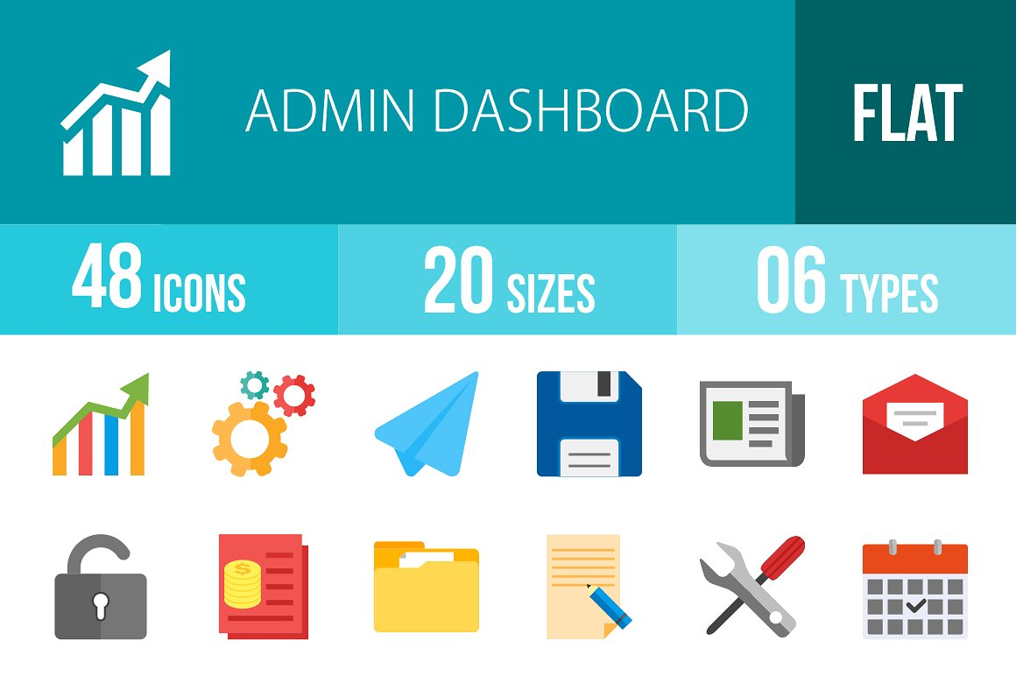

**Fig. 1.1** Iconography -icons-

### 1.2.2 Layout

The layout of the Dashboard is sawing how the data are placed together or not, if they are in the correct order and size, and if they fill correct the entire Dashboard page without useless empty spaces. The layout need to follow some general rules that will be explained in details below.

#### 1.2.2.1 Group related data together

Once all the data that we what to use for our Dashboard are gathered need to be grouped together and to be related to each other. The data need to be visualized with the right size and in the right position to be able to highlight the most important parts of the Dashboard.

#### 1.2.2.2 Keep uniform size

The size of the icons or the graphs is important to be the same and similar to reduce the distractions and to be able to identify all the features in the screen. This method helps to make the design easier and geometrically correct. Different visualizations techniques can be created and placed together on the same screen, this can give different points of view to the dataset that need to be visualised.

Furthermore, the figure below is giving an example of a Dashboard page with the incorrect and correct layout.

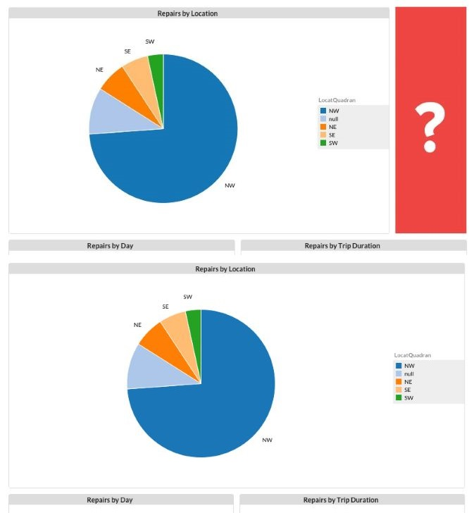

**Fig. 1.2** Layout -Wrong & Correct-

#### 1.2.2.3 Put limits to your data

One other parameter that need to be considered is to put reasonable limits to the data that will include on the Dashboard because the big amount of data may affect opposite and to distract the user.

The data need to visualised correct and to be understandable from the users as the below figure is sawing.

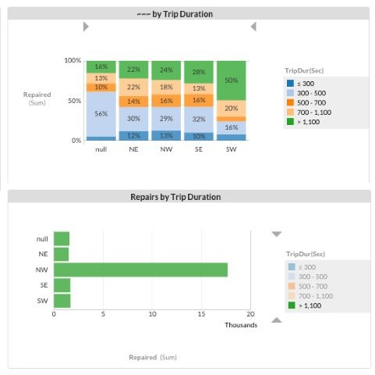

**Fig. 1.3** Data limits

### 1.2.3 Colours

One of the most important things to create a good Dashboard is the colours. Many users cannot understand the importance of choosing the correct colours and is the first mistake that are doing when they are designing a Dashboard. Below are some colour parameters that the user need to take in advance

#### 1.2.3.1 Leverage contrast

The correct and good choice of colours can be a good start for the Dashboard to make the data that need to be visualized clear to the audience.

Different colours combination need to be visualised to make the data easier for distinguishing the difference. The combination of the colours is important and need to be chosen carefully.

#### 1.2.3.2 Use colours only for specific reasons

The colours in the Dashboard need to be used only to serve a specific reason, for example, when is needed to highlight something and to put the attention of the audience to that specific panel of information.

In the other hand, colours can be used also when a group of data need to visualised together on the same chart and need be to separate from each other. From the different colours is easy to understand the different data information that are placed together.

The figure below is sawing a chart with different information in the same table with different colours.

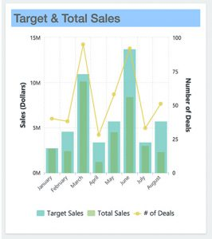

**Fig. 1.4** Colour combination

A good method for choosing colours is to have not more than six different colours in the visualization part, because the use of many different colours will make difficult for the users to understand the difference between the meanings of the datasets.

The use of natural colours is good to distinguish the information and the use of bright or dark colours for highlighting the important things.

When the colours are used, the programmer need to be aware that the background colour is the correct also to make the other colours visible to the user to understand them.

Important here is to remember always that as long as the question **“What purpose does this colour serve, and will it serve it effectively?”** can be answered then the use of colour is been chosen correctly.

#### 1.2.3.3 Pay attention to the meaning of colours

Important information about the colours is that they are not only colours but they have also a background meaning.

For instance, when the colours red and green will be used most of the people will understand that red is colour to highlight something bad or to put a warning and the green colour to highlight something good. Another example is with red and blue colours that anyone can associate them with hot (red) and cold (blue).

The use of the colours needs to be with a meaning for example the use of two different colours means that are two different information or for highlighting something. Never use different colour to represent the same thing.

Simple colours like black and white is good to be used for the Dashboard because sometimes the simplest is also and the best way to represent something.

The Figure below is representing some colour combinations with white and black letters.

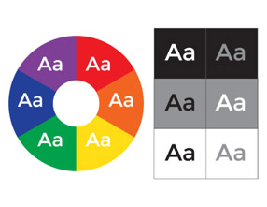

**Fig. 1.5** Colour combination

#### 1.2.3.4 Test for colour blindness

Another important thing that need to be taken in account to choose the colours for the Dashboard is for the users that have colour blindness, they cannot recognise well the different colours, like red and green that are almost the same for them.

Statistics shows that one in twenty users is colour-blind. The colour blindness problem can be solved thanks to some simulator programs like Colour Brewer, Vischeck e.t.c. Those programs can make the Dashboard visible to all the users and all of them to understand the differences between the colours.

Furthermore, the below Figure is an example of a Dashboard for colour-blind users.

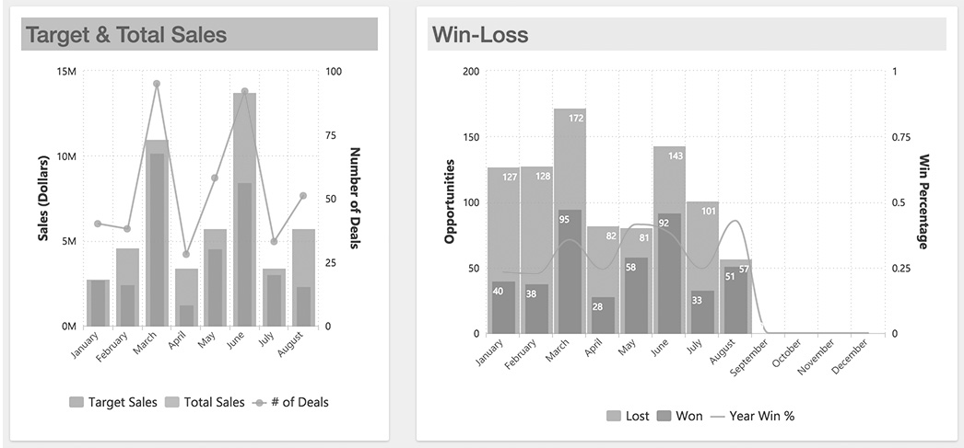

**Fig. 1.6** Colour-blind Dashboard

### 1.2.4 Fonts

After the colour part, another important thing for the design is the fonts of the letters that will be used. Most of the times the general rule for the Font size is, 12 for Times New Roman and 10 for Arial. Keep in mind than all the fonts must be maximum three times the size of the original Font when is needed to write something with bigger font.

#### 1.2.4.1 Keep standard your font sizes

The goal is to design a Dashboard with homogenous environment that will be easy to give emphasis to the words and let the users to understand it.

An example of the correct use of the fonts is given on the below figure.

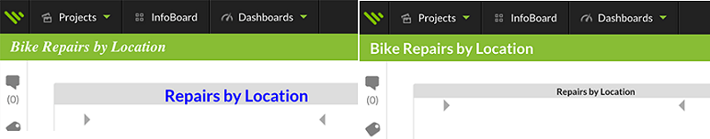

**Fig. 1.7** Font size

There are two main categories of fonts the Serif and the Sans-Serif families. Both of them have a different purpose in the designing part.

For instance, Serif font is suitable for the main the need to be included because is easier for the user to read it. On the other hand, Sans-serif fonts are more suitable for short texts, like headlines or words that need to give emphasis because the Sans-serif font attract the attention of the user easier than the Serif Font.

The designer need to determine also how will be the space between the lines and to determine how will be the space between the words or the individual letters. Those simple details can make the text better or not.

Most of the times the users tend to see first what is bigger in the screen without paying attention on the font, that is the reason that the headlines must be always bigger that the other text.

#### 1.2.4.2 Combining fonts and colours together

The final part is to combine the fonts and the colours together in the way that both of them can be combined well together. The colours can give a different point of view on the text, sometimes good and sometimes bad.

For instance, do not design dark text together with dark background or white text with a bright background. Another tip is not to use bright colours for the font with bright background, like yellow font and green background. This will confuse the users when they try to read something and probably will make the eye vision difficult.

The figure below is sawing some colour combinations between fonts and background

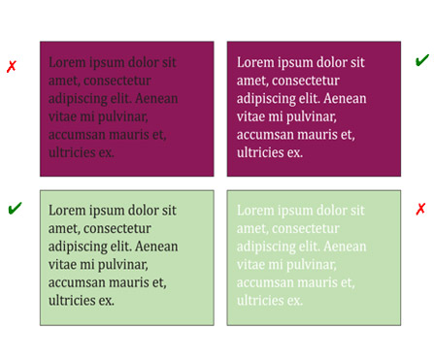

**Fig. 1.8** Combination of fonts and backgrounds colours

## 1.3 Visualization of the Dashboard

The part of visualization is the part that will be decide how will visualize the datasets, for instance with toolbars charts, pies, etc. On this part, it will be a combination between the information that had been gathered from the interview part with the visualization techniques that will be used to visualise that information.

The way that the designer it will represent the data is the key to visualize big amount of datasets together and let the users to analyse them easy and without any problems.

Furthermore, they are some main visualization types and charts that can be used for the designing part. Those visualization types are the bellow ones:

* **Tabular format:** This format is one of the best when we want to visualize exact amount of numbers because we can represent them in rows and columns and they can analyse any kind of information and the summary of them. Unfortunately, this format is not so good if we want to analyse and compare different data together because the Tabular format it will be very complicated and difficult for the user to analyse it.
* **Line charts:** This format is good when we want to visualize continuous data over time and to see the evolution of them. Line charts are very useful when we want to analyse our data, to observe them with different parameters, and to see if our goal is achieved or not.
* **Bar charts:** This format is the best when we want to analyse different data categories together in the same chart. Bar charts can be visualized horizontally or vertically and they fit very well when we have limited space on our Dashboard because of the reason that we can combine many data in the same chart. Most of the time one of the axis is the different data categories that we have and the other axis is the numerical data that they have for comparison.
* **Pie charts:** This format is the best when we want to compare different data together in the 100% and make the different parts of the charts important or not so important according to the percentage that they have from the total 100%. We need to keep in mind that until five different categories in the chart is acceptable after five categories the Pie will be more complicated and difficult from the user to understand it.
* **Area Charts**: They are like the line charts but with more information available inside.
* **Bubble Charts:** This format is to visualize the datasets in the three dimensions.
* **Funnel charts**: Are a type of chart, often used to represent stages in a sales process] and show the amount of potential revenue for each stage. This type of chart can also be useful in identifying potential problem areas in an organization’s sales processes. A funnel chart is similar to a stacked percent bar chart.
* **Heat Maps:** This format is suitable for showing a geographical area and the information about this area.

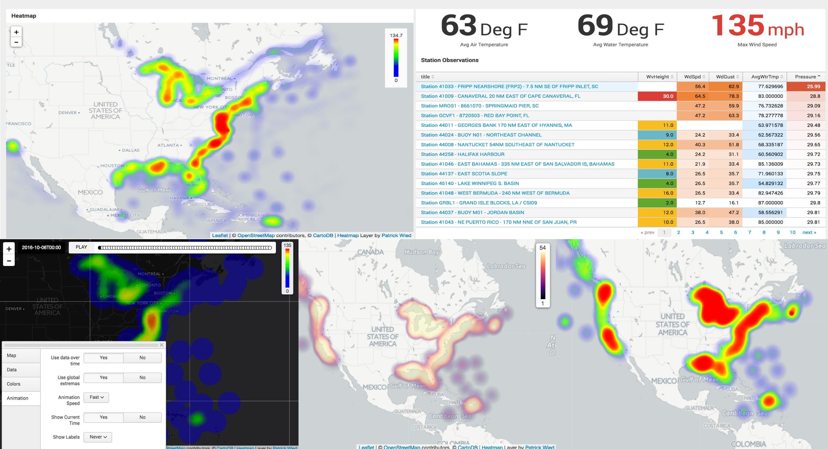

**Fig. 1.9** Heat maps

* **Radar chart:** This chart is a method of displaying multivariate data in the form of a two-dimensional chart of three or more quantitative variables represented on axes starting from the same point. The relative position and angle of the axes is typically uninformative. Alternative names include polar chart, web chart, spider chart, and star chart.
* **Pyramid Charts:** Are ideal for showing comparisons of data, using the thickness of layers to denote relative values.
* **Scatter Charts:**This chart is a type of a chart or mathematical diagram using Cartesian coordinates to display values for typically two variables for a set of data. The data are displayed as a collection of points, each having the value of one variable determining the position on the horizontal axis and the value of the other variable determining the position on the vertical axis.
* **Sparkline Charts:** The Sparkline is a very small line chart, typically drawn without axes or coordinates. It presents the general shape of the variation (typically over time) in some measurement, such as temperature or stock market price, in a simple and highly condensed way
* **Whisker Charts (Box Plots)**: This chart is a method for graphically depicting groups of numerical data through their quartiles. Box plots may also have lines extending vertically from the boxes (*whiskers*) indicating variability outside the upper and lower quartiles, hence the terms **box-and-whisker plot** and **box-and-whisker diagram**.

## 1.4 Visualisation Techniques

Let continue one-step further for the visualization part and decide how the Dashboard need to look. There are three visualisation categories the Static, the Animated and the combination of both of them together.

### 1.4.1 Static visualization

The Static visualization highlight only in the important information and keep the Dashboard static that means that the user is not able to do any additional actions because everything is on the main page. Static visualization can be a text or an image.

This visualization technique do not need any live browser or any add-ons because the data are designed not to change.

### 1.4.2 Interactive visualization

Interactive visualization give the option to the users to interact with the Dashboard. The Dashboard now looks animated with extra options like drill down and drill-through to explore all the information that are available.

For this visualization technique, the data can be also live-stream and to change through time. This visualization live-stream technique need some advance options like Flash player or HTML5.

### 1.4.3 Drilldowns vs. Drill-Through

As has been mentioned before the interactive Dashboard have some other options to achieve that like drill down, drill-through and zoom out/zoom in.

#### 1.4.3.1 Drilldowns

Drilldown technique means to be able to move from general data to more detail data, focusing on the things that the user want. The user is able here to search through deeper layers and to click to information in order to reveal more details.

#### 1.4.3.2 Drill-through

Drill-thought allow the user to jump from one report to another with the specific ability to focus on specific data. The users can right-click on the data that they want and to Drill Through the focused pages to get more detail that are available.

#### 1.4.3.3 Zooming

Zooming is the ability to dig deeper on the visualization part letting the user to click and see more details. For example, a map that the user can zoom into geographical places for more details, or a timeline chart with the ability to zoom and focus in a specific year and time for more details.

## 1.5 Validation of the Dashboard

The last and the most important step to finish the Dashboard is the validation part. The purpose of this step is to discover what the user’s opinion is for the Dashboard, because the user may have different opinion than the designer for the general view of the Dashboard.

Important for this part is the designer to star designing some beta versions of the Dashboard with the main ideas and datasets. This part is sawing in action how the combination between the main ideas and the datasets is together.

The last information that the designer need for the final design is to know how the Dashboard will interact with the user and if is good or not. The information it will come through the beta Dashboards that the designer will create and give to random users to evaluate it.

The validation part is especially important but need the correct use. Changing the Dashboard many times through the beta versions may affect the main idea of the Dashboard and destroy all the work that is done until now.

Through the evaluation of the Dashboard betas, the users can give some feedbacks for the design. The user experience is the most important parameter to understand how useful the Dashboard is or not.

Letting the users to be interacted with the Dashboard beta in daily base can make the designing part easier because through that the designer can ask the users opinion for how to make the Dashboard better and more useful.

The users can answer to some basic questions like the following one. “How they prefer the data to be visualized”, or “what kind of data and information are better”, or “what is important for them to understand the datasets”?

After the questions, the designer can also ask the users to draw their basic ideas if they want what, or to give some small examples about how they think that the Dashboard can be better.

During this procedure, the design of the Dashboard can be improved and the designer can solve in advance problems that has not thought before the final Dashboard design.

### 1.5.1 Build a Wireframe

Important step for the validation of the Dashboard is to create those beta versions of the Dashboard. The first step of those beta versions is called wireframe. Wireframe is nothing more than a basic design of the dashboard with all the datasets together to saw how they look when will be visualised

The wireframe more or less is the draft version of the Dashboard and looks more like a painting than an application, most of the times the main ideas can be designed first on a paper and then to proceed to the programing part.

The wireframe is sawing to the designer more or less how he will distribute the space that he has and how he will put the charts the buttons the images and the data all together. Knowing from the beginning where to put on the Dashboard all these charts or buttons or images etc. can save precious time from the programming part.

Furthermore the below figure is an example of a possible Dashboard wireframe.

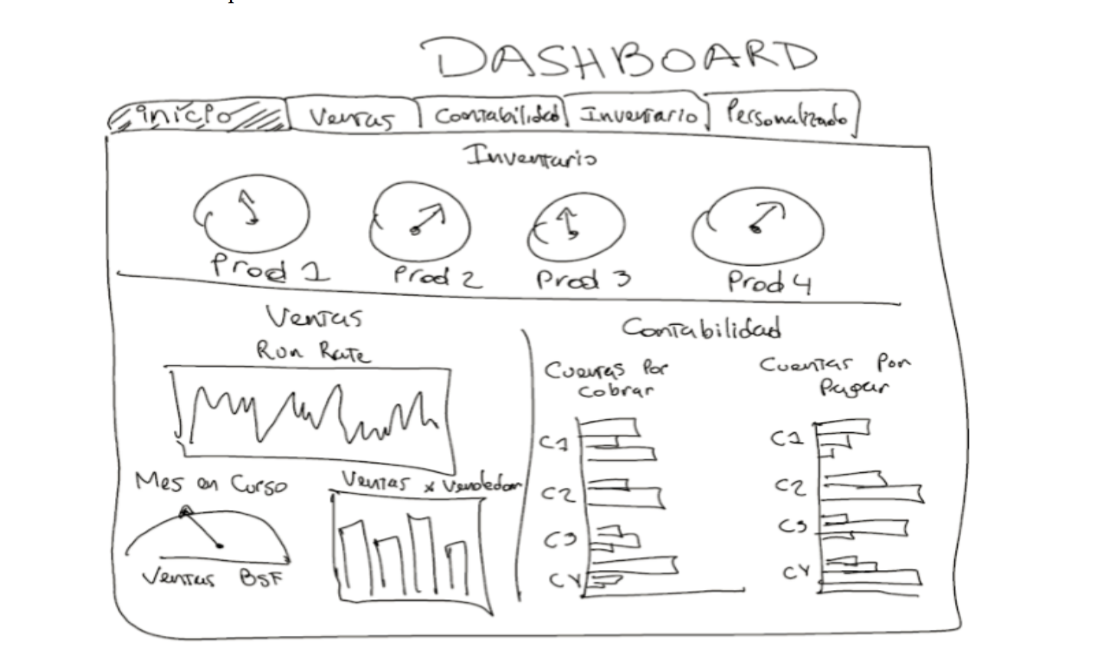

**Fig. 1.10** Example of Dashboard Wireframe

### 1.5.2 Build prototypes

After the wireframe done, time now is to build the first prototype of the final view of the Dashboard, but not the final version of it. Below is an example of a prototype.

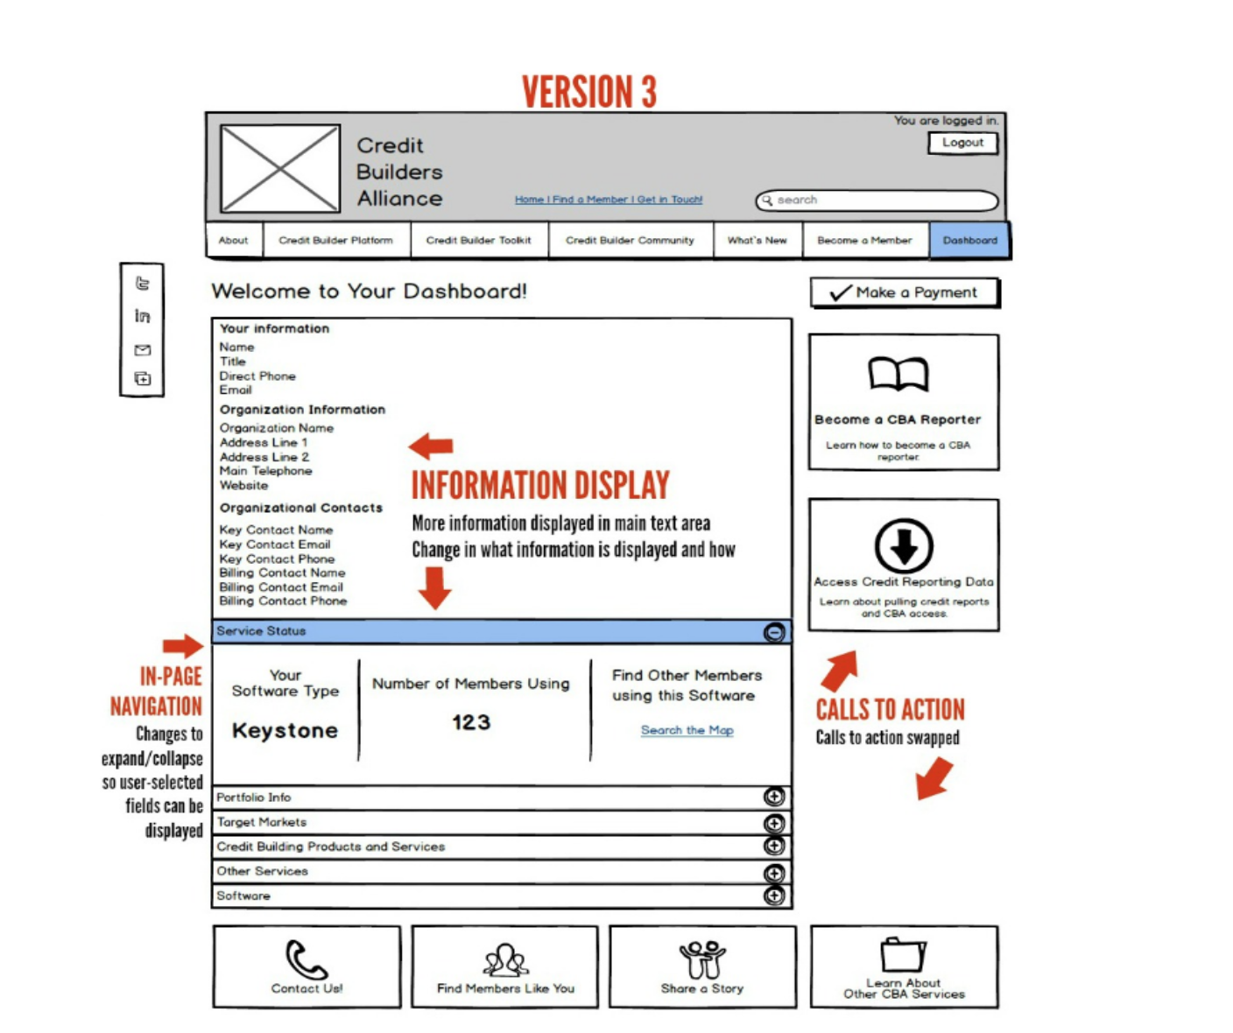

**Fig. 1.11** Dashboard prototype

As the ***Fig. 1.11*** is showing This will not going to be the final version of the Dashboard because can exist more than one versions, the design can be developed more and more over time and over the prototypes with improvements until to obtain the desirable design.

The feedbacks from the users is the important parameter here to know until when the Dashboard need to be improved. When the users star to give more positive feedbacks than negative ones then the improvement part is almost done is almost impossible the Dashboard to be for all the users perfect so is normal to have and some negative feedbacks.

### 1.5.3 Regularly tests and upgrades

Finally and important is when the design is finished and the final Dashboard we need still to not stop searching for what we can do better. We need to keep testing our Dashboard and to still take in account all the feedbacks from the entire user. We need to remember that everything needs to be evolved over time and to have new updated versions of our Dashboard in the future.

## 1.6 Future work of Dashboard Design

Everything that is evolved with the informatics and technology need to keep evolving through time, the same is with the Dashboards. Is important for every Dashboard to be the same useful like the first day until the end.

Below are some important things for the future of Dashboard design that designers need to do for future Dashboard designing part:

* **Simpler Interfaces:** Simpler interfaces means that the designer need to create a successful interface with a good user experience easy to understand and easy to navigate. No more big letters without a purpose, no more many colours, no more three-dimension treatments that can distract the user. Remember that simpler does not mean that just put text and that is all, simpler mean to provide an easy and useful user experience.
* **Needs of the On-the-Go User (Mobility):** As technological evolution keep growing so much the users are more and more attached to their phones and tables so that means that the Dashboard need to provide them good mobility experience.
* **Colour Balance:** As was mentioned before no more many colours without meaning. There is often problem in some Dashboards to be either too much colourful or to less. The design needs to be “Colour Balanced” with the meaning of monochromatic background colours in contrast with bright colours when something need to be highlighted on the datasets.
* **Iconography**: Less is more, is the main rule of the future Dashboards and Iconography is a part of that. Designers need to create more often Dashboards with small icons or photos with short descriptions to let the user to understand directly what they want to see without reading the content. Some “smart” photos can give an efficient and quicker navigation interface.
* **Dynamic Dashboards:** Dynamic Dashboards is the future of Dashboards for the reason that any dataset need to be able to be upgraded and interact with the Dashboard at any time. The designer need to be able to customize the Dashboard at any time and to provide new things to the users as the technology and the Internet evolves. Without a Dynamic Dashboard, it will impossible for the designer to upgrade the Dashboard for future needs.
* **Interactive and live data:** Interactive Dashboards are needed in our days for the reason that the users are more technological efficient than in the past and it will be more interesting for them to interact with the data and to have more options to analyse them. All the techniques that was analysed before like zooming, drilldowns and drill through plus elements like videos need to be includes in the design. The most important thing now is the Data to be live, users are more interested to see what is happening at the moment that they are searching for something than to have only past datasets.
* **Dashboards with High Location Technology:** In the past, the traditional computer Dashboards were using static maps for analysing different areas when the user wanted. Now with the mobility evolution the Dashboards need to be more efficient and with the use of mobile Gps to be able to analyse datasets that they are in the same geographical area automatically.
* **Future prediction on Dashboards:** Until now, the user is used to see on internet weather forecasts, election forecasts or in mobile phones possible text prediction according to the text history. The next big thing on the Dashboards is the data analytic predictions. Analysing information from different datasets can be useful to predict patterns and facts that are inside the data and to help the users or the companies to organise their plans better.

# Analysis of the case MASTEAM

One of the most important things for the creation of a successful Dashboard is to know in advance for what reason and why we are designing something. This will give us an advantage to create a Dashboard with the most relevant information that the user want to observe and analyse.

To know in advance that important information is needed to know how the user is thinking and what kind of information want to see on the Dashboard. To achieve that and to gather those information some interviews between the user and the programmer need to be arranged as was been explained already on the **CHAPTER 1**.

For the purpose of the MASTEAM Dashboard, an interview with the coordinator of the MASTEAM Master Mr. Rincon Rivera David was been arranged. This interview can help us to know in advance and gather that information that are important for him to create a successful Dashboard.

## 2.1 Creation of the Interview questions

After defining the user or users that we need for the interview part (Mr. David Rivera Rincon in our case), the next step is to prepare a list with possible interview questions. Those questions will refer to the MASTEAM topics and will have an explanation why are important for the designing part according to us.

Making correct or wrong questions is the same valuable, because from that it will be more understandable what is important for the Dashboard through the correct questions and what is not through the wrong questions.

The main idea for how the Dashboard need to be is most of the times different for the prospect of the designer and from the prospect of the user. Most of the times the designer probably does not know how important or not is what is designing or what is the purpose of putting a specific information on the Dashboard.

For the purpose of the MASTEAM interview, was been created a list with possible questions with an explanation to each of them why they are important to be included on the Dashboard. Following are the interview questions for the MASTEAM case.

* **How much are the Tuition Fees:** Is important to know how much the Master cost, or what are the other economical information that the Master include.
* **Enrolment status:** Maybe the most important thing that the user want to see on an Educational Dashboard because can see any time the current status of all the Master, students and enrolment applications.
* **How many are the courses on the MASTEAM and which are they:** Like in any education institute one of the most important thing that the user what to know is the courses that are offered.
* **The total grades of the courses:** Is important for the evaluation of any subject to know how the grades of any student are.
* **The percentage of the graduated student:** Important parameter for the evaluation of the master in total every year and how successful the Master is.
* **Information about the students like age, gender, nationality:** Any information about the students of a master are important, before the enrolment and during the Master for the evaluation system.
* **How many are the new students in each semester:** Important information because the master is divided in 2 periods and they are new students every autumn and spring semester.
* **How many internships the University is providing and what kind:** Useful information to know any time what are the internships that the MASTEA provide and to inform anyone that is interested.
* **How many students are going after the MASTEAM for a PHD:** Maybe important information to know what is the percentage of the students that are going for PHD?
* **How many are the professors that the master have and how many of them with a PHD degree:** Possible information from someone that is interested for the status of the professors of the master.
* **The professors that are involved in the research projects and the students that are participating:** Possible useful information about the professors and the students that are involved on university projects to know for evaluation purposes.
* **The range of the professor’s salary:** Possible useful information about the economic status of the master.
* **What are the external activities that the MASTEAM offer:** Useful information to inform the students about any activities that the master offer like seminars, workshops, etc.?
* **Motilities and Transportations about the students:** Like any Master degree they are students that are coming from other Universities for a double degree or for Erasmus or the opposite students of the MASTEAM are going to other Universities for the same purposes.
* **What is the Evaluation system of the MASTEAM:** Any information that can be included in the Dashboard about evaluation purposes is important.

The creation of the interview questions is a part that most of the times is individual and different for every designer that want to design a Dashboard. A successful formula for specific questions or instructions that the designer can follow does not exit, every Dashboard is different and with different purpose.

Every possible question that can be created for the interview part is totally individual and based on what the designer is thinking that is important for the Dashboard or not. All the real important parts of the Dashboard they will come through and after the interview part.

Furthermore we need to keep in mind that every possible question that the designer think that is important for him or not, maybe it will not going to be the same important for the user that is involved in the interview. Is possible to have similar thoughts or very different ones.

As was been mentioned before does not matter if the questions are correct or not, the purpose of the interview is to learn what are the most relevant information for the Dashboard and through them to evolve what is already planned.

During the interview part, not only the designer can be effected positive but also the user. The designer knows better what can be visualised or not, and can explain to the user through the interview, that every possible dataset can be visualised in ways that the user may does not thought before.

## 2.2 Interview part

After the end of the interview with Mr. David Rivera Rincon, many useful things were mentioned about the Master and for the important information that need to be included on the Dashboard, or which information does not need to be included.

The interview was very useful for understanding how an educational Dashboard needs to be, what the purpose of every information that is inside is and how need to be visualised.

The first mistake according to the questions that was made for the MASTEAM, was that all the questions were made from the perception of what a student want to see on the Dashboard and not the coordinator.

Let us now to take one by one all the questions that were asked to Mr. David Rivera Rincon and to point what were the most important information according to him that need to be include on the Dashboard.

According to the interview only the bellow information are very useful and important to be included on the Dashboard:

* **Enrolment:** The most important thing that need to be on the Dashboard because include all the information about the students, the old one and the new one that enrolled to study on the MASTEAM. Also, include the information about the percentage off the accepted applications and the rejected one.
* **The Courses:** The number of the courses, the information about them and the edition of the course according to the year and the semester.
* **Number of students:** The number of students that the MASTEAM has in total and in each course individual. Also important here is the number of new students that are enrolled in each semester.
* **Grades:** The grades of the students in average and in each course individual. Also the total average of the grade on each course individual.
* **Percentage of Graduated students:** Here is important to know the percentage of the graduated student, when they start and when they finish. Here need to be included also the percentage of the students that they failed to Graduate or they quit.
* **Information about the students:** Information that are important about the students are age, gender and the geographical region if they are European citizens or not. Important for this part is also the information about the universities that the students were studying before, for instance if they had studied on UPC or is a different Spanish university or studied on abroad universities.
* **Information about Internships:** The information that are important for this part is the students that were evolved in the internships and the evaluation that they have, also a list of the top companies that a student can do an internship.
* **Information about Motilities:** Important for this part, is the information about the students that are coming to study on MASTEAM which are from ERASMUS or from double degree programs and the opposite students from MASTEAM to go abroad. Important to know here are the number of the students, the grades on each lesson and the average grade in total.
* **The evaluation System:** Final but not least the Dashboard need to provide an evaluation system that every university has and need for each Master individual, this can evaluate all the activities that the MASTEAM provide and give a total score that is important for the Government.

After the end of the interview part, is clearer now what kind of information need to be included on the MASTEAM Dashboard and how they should be visualised. One important issue that exist for all the personal information is the human privacy and if someone is allowed to have those information or not.

Probably some of the information that are needed for the Dashboard they will accessible to gather them and to have them and some of them they will be closed and private due to data privacy.

Furthermore, another issue that maybe exist is that, if someone want to have access to datasets that contain information about the university needs to be also an authorized user from the UPC directory. This may be a problem for the programmer but not for the coordinator of the Master because he is an authorized user and he has the wright to have access to that information.

Finally, after all the useful information that we learned from the interview and taking into account all the issues about the data privacy, we need to decide what datasets we will use on the Dashboard. Those datasets they will contain the most important information for the MASTEAM according to the interview part and what information we are allowed to have or not from the data privacy issue.

# Design a Dashboard

Now that the interview part is done and is clear what kind of information need to be included on the MASTEAM Dashboard, is time to fill the datasets with the information that we need. A list of the final datasets that will be included to the Dashboard need to be created and to way that those datasets will be visualized through the MASTEAM Dashboard.

Due to the data privacy issue is preferred the creation and the use of non-real datasets that they will contain fake but relevant information about the MASTEAM case. The creation of those possible non-real dataset examples thy will be explained below.

The datasets they will be on CSV format and they will include information about (i) the enrolment, (ii) all the information about the students including new and old students and (iii) all the information about the courses and the grades.

All the non-real datasets that were created this does not mean that the Dashboard is created only for that specific information, all the CSV files can be manipulated and changed as is needed without changing anything on the Dashboard. Every kind of information is able to be visualize through the Dashboard with or without any changes according to the form of the datasets.

All the above information will be included on the Dashboard as individual categories of the Dashboard and like a combination with all the datasets together to provide the general view of the Dashboard in only one screen.

The general idea is to create a main Dashboard page including the most important information about the MASTEAM all together in one page for the user to be able from the first moment to have a general idea about the master.

After creating that main page main Dashboard, the next step is to continue with the creation of the other pages that will contain all the detail information about the datasets individual. For instance one page with all the information about the students, one page about the detail information about the courses and the grades and so one.

## 3.1 Creation of the datasets on CSV format

For the creation of the Dashboard is needed to have the final form of the datasets that will be used providing them for the designing part. As was mentioned before is not possible to have the original datasets from the MASTEAM so some fake datasets was created on CSV format. Those datasets that will be visualized on the Dashboard they will give an example of a possible MASTEAM Dashboard.

### 3.1.1 Enrolment CSV dataset

The first example of dataset that was been created was the enrolment CSV file that contain information about the students that enrolled for the years 2015, 2016 and 2017.

The enrolment CSV file it will contain the total application number that the interested students made for the MASTEAM, the number of the applications that had been accepted, the number of the rejected one and from the accepted applications the number of the student that finally enrolled.

Furthermore, on the figure ***Fig. 3.1*** is an example from a possible CSV file with the enrolment information.

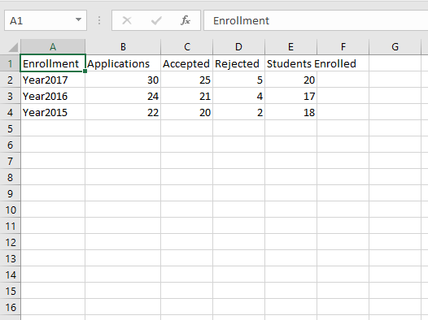

**Fig. 3.1** Enrolment dataset

### 3.1.2 Students information CSV dataset

The second CSV dataset that was been created is about the personal information of each student of the MASTEAM. This CSV dataset contain the information about the name of the student, the age, the gender, their country, the semester that is coming to the university and the date, the nationality if it is European citizen or Non-European and the current id number that the University is giving to them.

Furthermore, on the figure ***Fig. 3.2*** is an example from a possible CSV file that contain the student information.

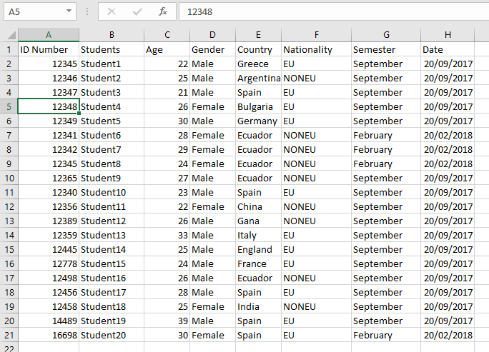

**Fig. 3.2** Students personal info

### 3.1.3 Students grades CSV dataset

The third CSV dataset that was been created is about the individual grades of each student for all the courses. The CSV file contain the name of the student and the grades that obtained in all the courses that had enrolled.

Furthermore, the figure ***Fig. 3.3*** is an example from a possible CSV file that contain the student grades.

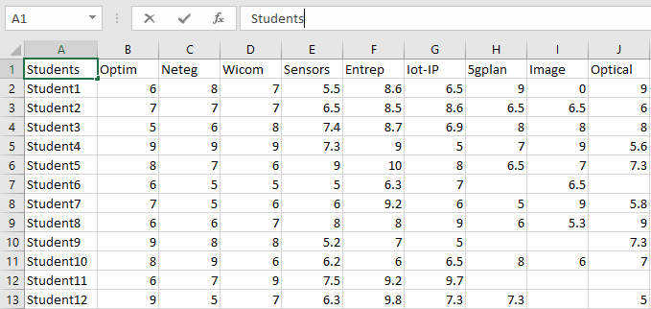

**Fig. 3.3** Students Grades

### 3.1.4 Courses and Grades CSV dataset

The fourth dataset that was been created is about the courses, the students that had been enrolled in each course and the grades of them.

Furthermore, the figure ***Fig. 3.4*** is a possible CSV file that contain the courses with the enrolled students and the grades.

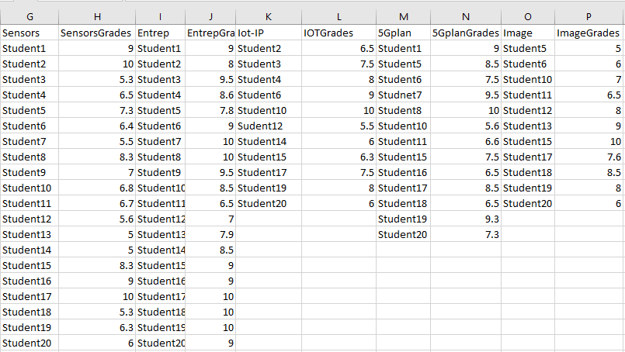

**Fig. 3.4** Courses Grades and enrolled student

### 3.1.5 Number of students per course CSV dataset

The fifth dataset that was been created is about the number of students that each course had for the years 2015, 2016 and 2017.

Furthermore, the figure ***Fig. 3.5*** is giving a possible CSV file that contain the number of students per course for the years 2015, 2016 and 2017.

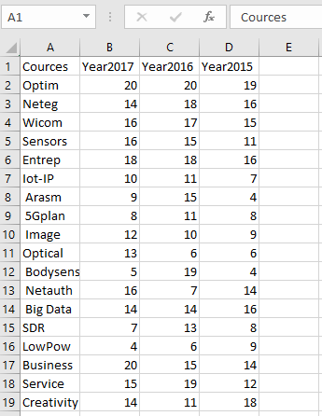

**Fig. 3.5** Number of student per course

## 3.2 Build the dataset Wireframe

Now that the datasets was been created, the next step is to create the Wireframe. The Wireframe is the procedure before the programming part, on this part the main ideas about how the data need to be visualized on the Dashboard are going to be created on a piece of paper.

The paper with the draw of the Dashboard including the datasets on it is what Wireframe means.

For the MASTEAM Dashboard the idea is to create a main page with the important information about the MASTEAM and then different subpages with all the datasets in details.

### 3.2.1 Main page Wireframe

The creation of the main page of the Dashboard is maybe the most important one, because through that need to provide to the user the general view of the MASTEAM only in one page.

The user need to understand from the beginning what is the status of the MASTEAM without spending time to search for something from the begging. The main page it will contain information about the enrolment, information about the students and information about the courses.

The enrolment part will have the number of the total applications, the number of the accepted one and the rejected one and the number of the final enrolled one.

The information about the enrolled student will be the number of the male and female students and the number of the European and Non-European one.

The last part is will be the courses information with the number of students that the courses had for the years 2015, 2016 and 2017.

### 3.2.2 Students page Wireframe

The students page it will contain the CSV files that contain all the information about the students all together. The first part of the Students page it will contain all the student personal information like name, id number, age, gender, nationality, enrolment date and the semester that they will start.

The second part of the Students page it will contain the grades of each student in each courses that was been enrolled and the final average grade that had obtain through all of them.

### 3.3.3 Courses page Wireframe

The page that will contain the information about the courses it will have the courses and the students that had enrolled in each course individual, then it will have the grades of the students per course.

This part is similar to the Students wireframe because contain also the grades of the students, but it will be with different visualization technique as was maintained on the **3.1.4 Courses and Grades CSV dataset**.

Furthermore, the Courses page it will contain the average grade per subject according to the students grades that they obtained in each course separately, and the total number of students from the previous year 2015, 2016 and 2017.

# Implementation of the Dashboard

The implementation of the Dashboard is ready now to start. After the creation of the questions for the interview part, the interview, the creation of the possible datasets and the creation of the wireframes if finally the time for the programing part and the creation of the Dashboard.

Now is the time to proceed with the implementation of the wireframes that was been explained on ***3.2 Build the dataset Wireframe*** to real Dashboard pages through the programing part with R-studio and the Shiny Dashboard.

R-studio is a powerful programing platform for big data analyses and for complex mathematical equations. R-Shiny is an extension for R-studio that helps to make interactive web applications for visualizing datasets. R-Shiny can analyse the datasets that was been created and at the same time to visualise them with different visualization techniques.

The Dashboard contain three main categories, the first page that is the MASTEAM Dashboard page, the second page that is the Students page and the third page that is the Subject page.

## 4.1 Implementation of the main Dashboard page

The main page is ready now for implementation, following the wireframe that was explained on the subchapter **3.2.1 Main page Wireframe**.The programing part is done and the figure ***Fig. 4.2*** is showing how the main Dashboard page looks.

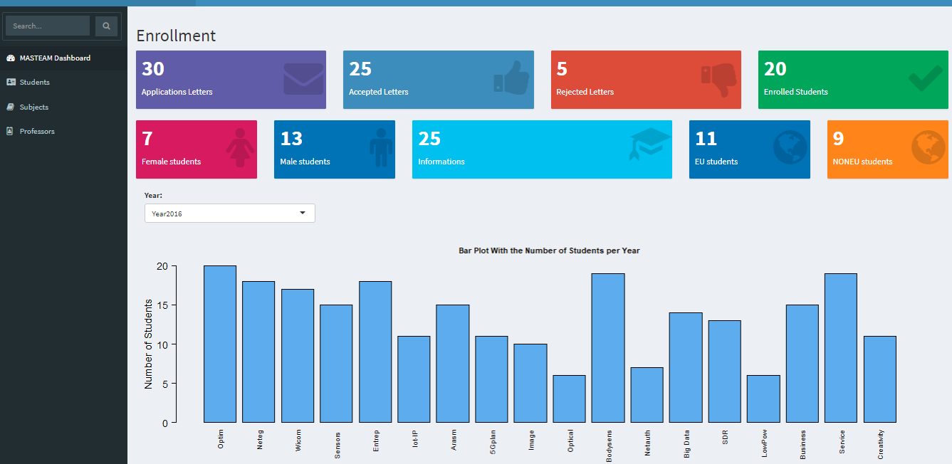

**Fig. 4.2** Main Dashboard page

The figure ***Fig. 4.2*** is showing how the main page of the Dashboard looks.

From the figure, ***Fig. 4.2*** is not easy to understand all the details that the main page has, so additional separate figures from the main page was been made to explain the main page with details.

The upper part of the Dashboard is clearer and the figure ***Fig. 4.3*** is showing the visualization part for the current enrolment status.

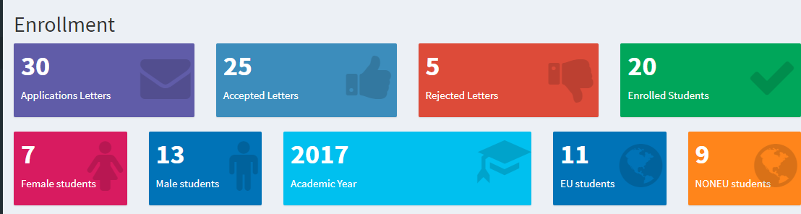

**Fig. 4.3** Main Dashboard page –Upper part-

The purple colour box contain the number of the total application letters, the light-blue box contain the accepted letters, the red box contain the number of the rejected letters and the green box contain the final enrolled student for the academic year 2017, as the aqua colour box is showing.

Furthermore, according to the Students information dataset that was explaind on the subchapter **3.1.2 Students information CSV dataset**, the R studio was programmed to count the total number of the female and male student and the total number of the European and Non-European student.

The maroon colour box contain the number of the female student and the bleu box the number of the male student, the other blue box on the right side contain the number of the European student and the orange box the number of the Non-European. Is important to be mentioned here that the names of the colours are the exact names that the R studio use to visualise them.

Now that the upper part of the main page is clear, the bottom part of the main page can be explained now according to the figure ***Fig. 4.4***.

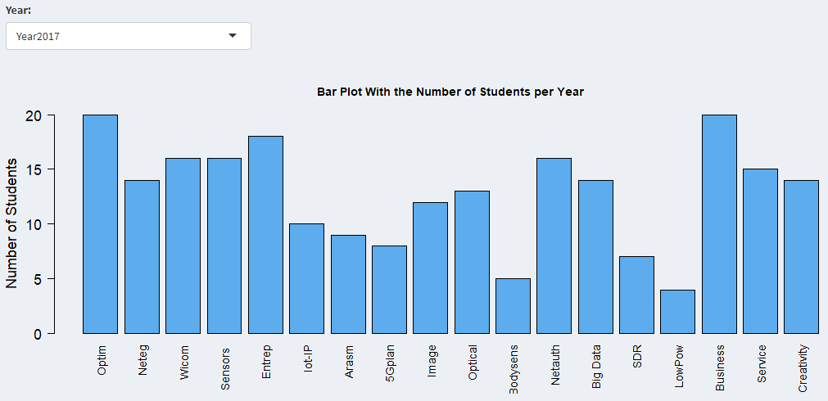

**Fig. 4.4** Main Dashboard page -Bottom part-

From the figure ***Fig. 4.4***, can observe the bar plot that contain all the subject names on the horizontal axis and the number of students in each subject on the vertical axis.

The bar plot is also programmed to make the same visualization for the three years 2015, 2016 and 2017 as the figure ***Fig. 4.5*** is showing, according to the **3.1.4 Number of students per course CSV dataset**.

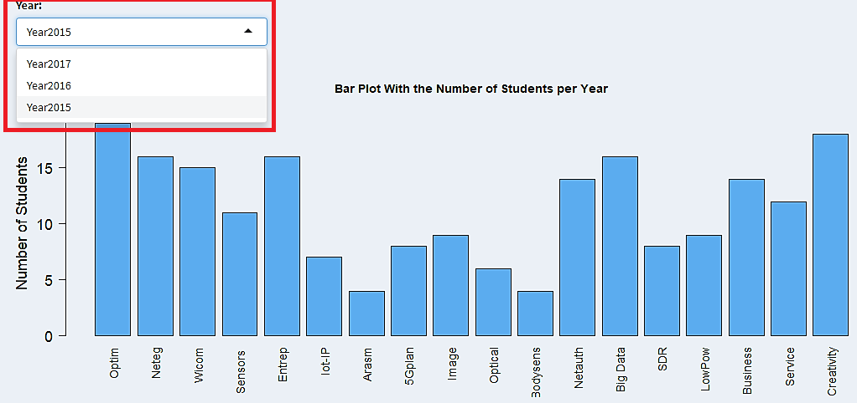

**Fig. 4.5** Main Dashboard page -bottom part/Years-

## 4.2 Implementation of the Students page

The second important page of the Dashboard, the Students page is ready now for the programming part and for visualizing the datasets, according to the wireframes on the subchapter **3.1.2 Students information CSV dataset** and **3.1.3 Students grades CSV dataset.**

The Students page is separated in four different subpages, the **Students Info** that contain the students information, the **Grades** that contain the students grades on each subject, the **Summary** that contain the average student grade and the **Percentage of graduated students**.

The programing is done and at the below sub chapters it will be an explanation how the Students page and the subpages look like.

### 4.2.1 Students Info subpage

The figure ***Fig. 4.6*** is sawing us the first subpage that contain the student personal data as has been mentioned on the subchapter **3.1.2 Students information CSV dataset**.

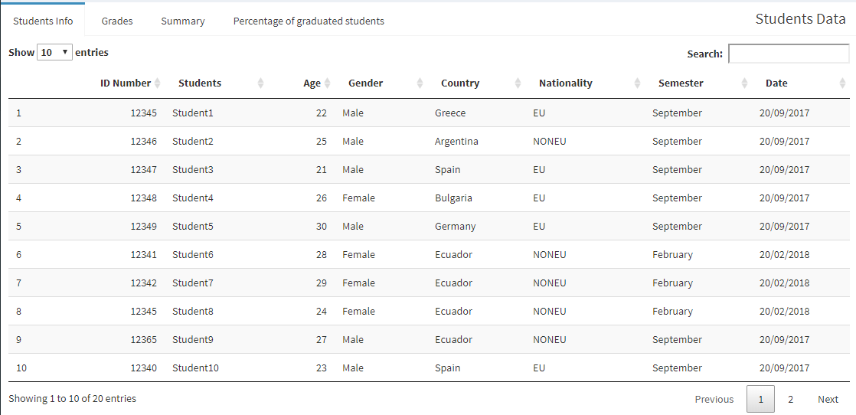

**Fig. 4.6** Students page –Students Info-

The Students Info subpage was programmed to have the ability to sort all the information according to what the user want, for instance sort the student names alphabetically or sort them from the age or from the gender, etc. The sorting part is coming from the small arrows that are next to each category and have the ability to sort the information downwards or upwards.

Finally on the Students Info subpage is also important the part that the user has the ability to search for a specific name through the “Search box” that is on the top left part of the window.

The figure below can give an example of the “Search box” use.

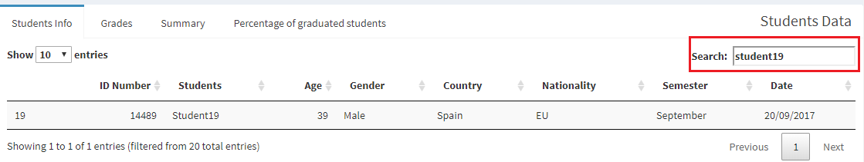

**Fig. 4.7** Students page -Search box-

### 4.2.2 Students Grades subpage

The subpage Grades from the Students page contains the information about the grades that the students have from the subjects that had enrolled and pass.

The dataset that was used for this visualization part is the dataset that has been mentioned on the subchapter **3.1.3 Students grades CSV dataset**.

The figure ***Fig. 4.8*** is showing the Grades page, this page was programmed with the same way and has the same abilities like the **4.2.1 Students Info subpage**.

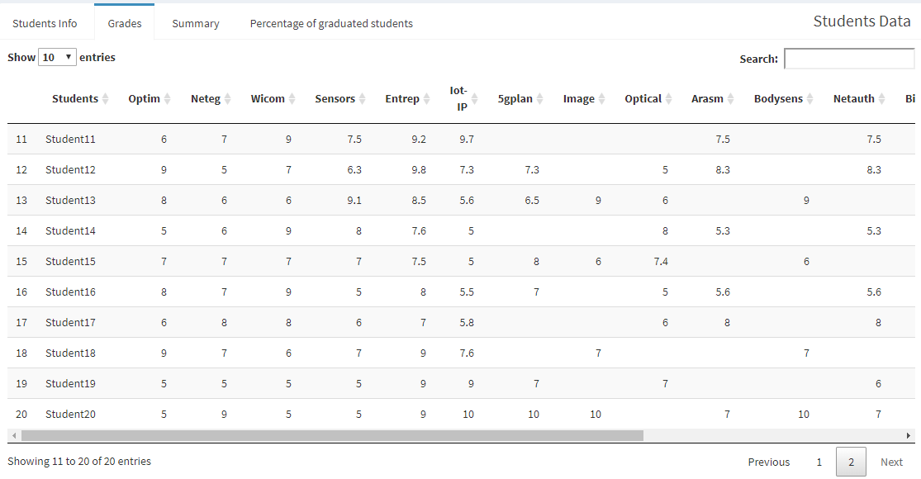

**Fig. 4.8** Students page –Grades-

The ***Fig. 4.8*** figure is showing the students and the grades that they have on the courses. Expect from the five first courses that are mandatory and all the columns were filled, they are many empty spaces on some courses and that because the students had not enrolled for that courses.

### 4.3.3 Students Summary subpage

The Summary subpage is the subpage that contain the average grade from all the students from the courses that had enrolled. The R program was programed to calculate the average grade of each student as the figure ***Fig. 4.9*** is showing.

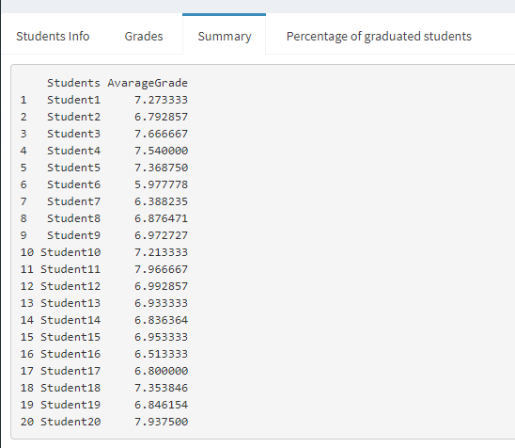

**Fig. 4.9** Students page - Summary-

## 4.3 Implementation of the Subject page

The third important page of the Dashboard, the Subject page is ready now for the programming part and for visualizing the datasets, according to the wireframes on the subchapter **3.1.4 Courses and Grades CSV dataset** and **3.1.5 Number of students per course CSV dataset**.

The Subject page is the page that contain the information about the courses of MASTEAM and was programmed in the same way like the ***4.2 Implementation of the Students page***.

The Subject page is separated in three different subpages, the **Subjects** subpage that contain the courses the students that each course has and the grades, the **Summary of Subjects** subpage that contain the average grade that each course has in total and final the **Number of Students per Subject** for the years 2015, 2016 and 2017.

The programing is done and at the below sub chapters will show how the Subject page and the subpages look like.

### 4.3.1 Subjects subpage

After the programing, the figure below is showing how the Subject subpage looks like.

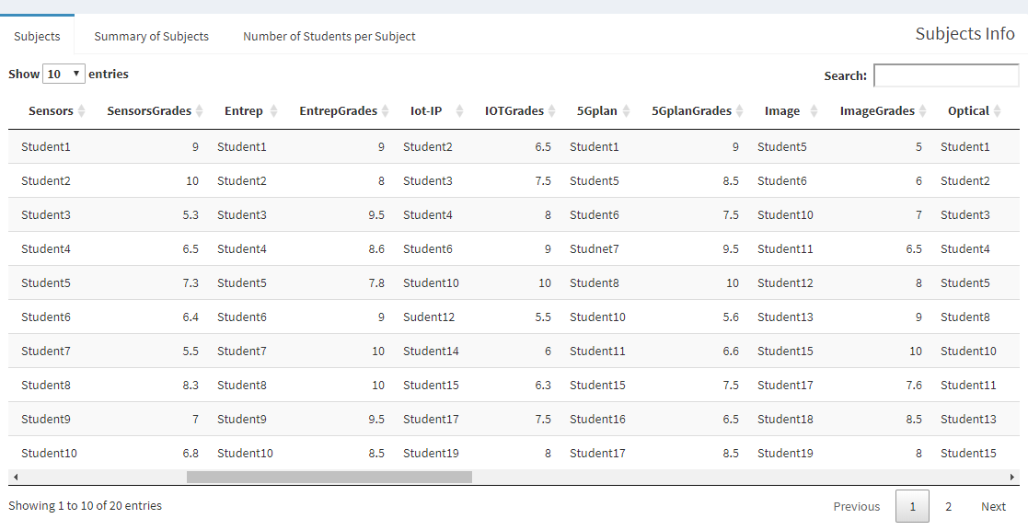

**Fig. 4.10** Subject page –Subjects-

The ***Fig. 4.10*** figure is showing the visualization part of the **3.1.4 Courses and Grades CSV dataset**.

This subpage is showing in one column the course and below it the students and the exact next column the course grades.

Can be noticed that not every course has the same students that is because every course has below only the students that was been enrolled for this course.

The programming part is the same like the ***4.2 Implementation of the Students page*,** with the same technics and abilities to sort the data downwards or upwards and to search for a specific information through the “Search box”.

### 4.3.2 Summary of Subjects subpage

The Summary of the Subjects subpage was programmed to calculate the grades of each student to the different courses and to return the average grade per course. The method is the same like **4.3.3 Students Summary subpage**.

The figure below is showing how the Summary of Subjects subpage looks like.

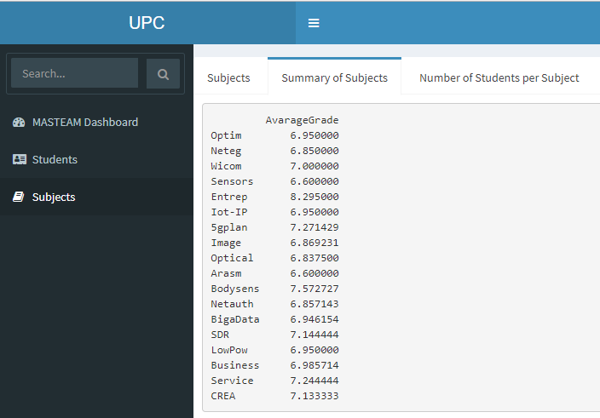

**Fig. 4.11** Subject page -Summary of Subjects-

### 4.3.3 Number of Students per Subject subpage

The subpage Number of students per Subject is contain the number of student that each course had in the three years of MASTEAM 2015, 2016 and 2017. The dataset that was used to visualise this subpage was mentioned on the subchapter **3.1.5 Number of students per course CSV dataset** that contain the information about the number of student per year.

The figure above can show how the Number of students per subject subpage looks like.

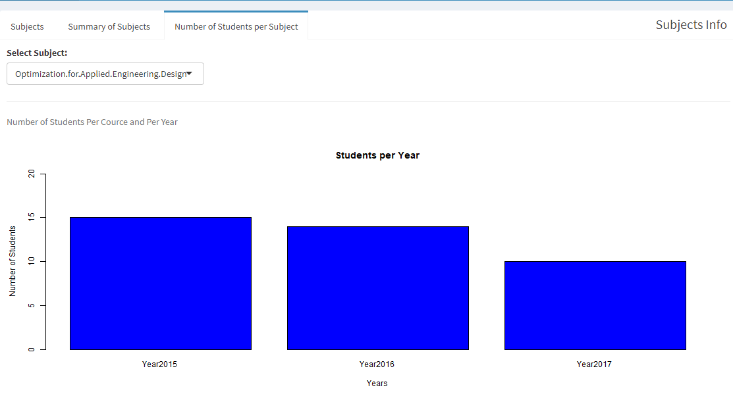

**Fig. 4.12** Subject page -Number of Student per Subject-

The figure ***Fig. 4.12*** is showing the bar plot that contain the years and a slider box on the top left place that contain all the courses. From the slider box is possible to select any course that the MASTEAM have and to obtain the number of student on the three different years.

The figure below is showing how the slider box looks like.

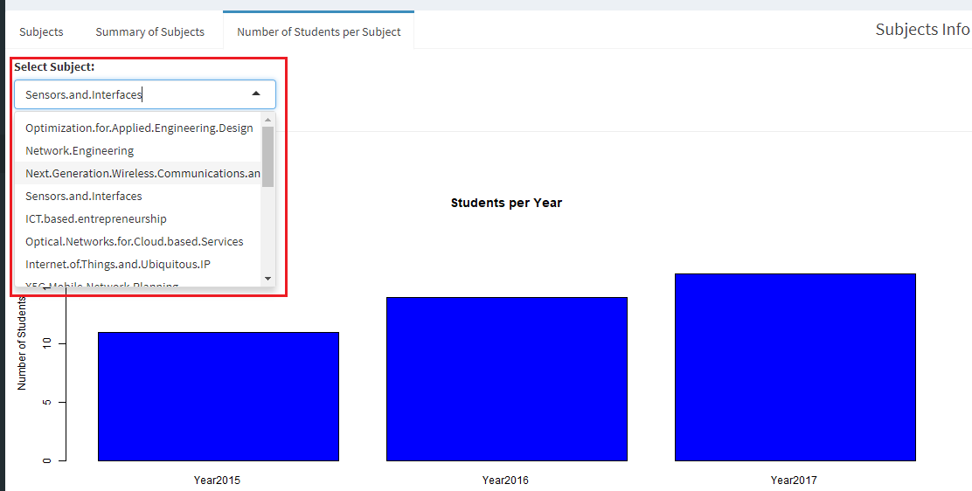

**Fig. 4.13** Number of Student per Subject -Slider Box-

# Rcode and Maintenance of the Dashboard

The Dashboard for the MASTEAM case is finally done and all the datasets and features are ready for work. The user can use now the MASTEAM Dashboard for the purposes of MASTEAM Master.

The user is able now to know what is the MASTEAM status and is able to take any additional decisions if is needed for making the Master better or to maintain it.

Until now, was explained how the procedure for making a Dashboard is from the begging until the end, from the interview part **Analysis of the case MASTEAM,** the designing part **Design a Dashboard** until the implementation part **Implementation of the Dashboard**. The only thing that was not explained until now is the programming part and how the R code for our Dashboard is.

This chapter it will explain some important parts from the R code and how they are working, the R code parts can be useful for the user to maintain the Dashboard for the future and to understand how the program is working if they want to change or add something.

## 5.1 R code explanation

This subchapter, it will explain how the R studio and R Shiny are working when someone wants to create a Dashboard. Furthermore and more specific it will explain what are the basic R code parts from the MASTEAM Dashboard and why has been programmed like this.

Every programing platform need some libraries to work, some libraries that you can call and you can program different tasks, the same is for R studio also and for the creation of the MASTEAM Dashboard was been used many libraries.

The creation of a Dashboard with the R Shiny is using the basic programing parts and parameters from R studio but is little bit different for the reason that here the program needs a server output to be able to visualise all the datasets on a webpage.

The R Shiny is divided in two parts the UI part and the server output part. The Dashboard can be crated in two different programing parts the UI.R and server.R as separate applications. or with only one application part that will contain both the UI and server output together. Both technics are the same and is up to the programmer how wants to program it.

The UI are acronyms from the “User Interface” and this part contain all the information about the code part that need to be visualised on the Dashboard page, with fewer words is the program for how the Dashboard page looks like.

The server output is the part that is taking all the parameters that was been programed on the UI part and is giving them the correct output for the server page to visualizing them.

For instance if the programmer need to program something on the UI, the results are obvious on the R console but not in the web page, to see the results on the web page the server output is needed.

### 5.1.1 Libraries explanations

The R studio contain many libraries for different computation parts. All the libraries that was used for developing the MASTEAM Dashboard they will be explained in details on this subchapter.

To use a library in R is easy with the command “library (name of the library)”.

The libraries that the MASTEAM Dashboard use are the following one with a brief explanation:

* **library(shiny)**: The basic library to start a shiny application
* **library(shinydashboard):** The library for starting a Dashboard
* **library(readxl):** The readxl package makes it easy to get data out of Excel and into R.
* **library(dplyr):** dplyr is a powerful R-package to transform and summarize tabular data with rows and columns.

http://genomicsclass.github.io/book/pages/dplyr_tutorial.html

* **library(data.table):** Fast aggregation of large data (e.g. 100GB in RAM), fast ordered joins, fast add/modify/delete of columns by group using no copies at all, list columns, friendly and fast character-separated-value read/write. Offers a natural and flexible syntax, for faster development.

<https://www.rdocumentation.org/packages/data.table/versions/1.11.4>

* **library(ngram):** An n-gram is a sequence of n "words" taken, in order, from a body of text. This is a collection of utilities for creating, displaying, summarizing, and "babbling" n-grams.

https://cran.r-project.org/web/packages/ngram/index.html

* **library(RColorBrewer):** Creates nice looking colour palettes especially for thematic maps.

<http://ugrad.stat.ubc.ca/R/library/RColorBrewer/html/ColorBrewer.html>

* library(tuple): Functions to find all matches or non-matches, orphans, and duplicate or other replicated elements.

https://cran.r-project.org/web/packages/tuple/index.html

* **library(shinyWidgets):** Some custom inputs widgets to use in Shiny applications, like a toggle switch to replace checkboxes and other components to pimp your apps.

https://cran.r-project.org/web/packages/shinyWidgets/index.html

* **library(ggplot2):** ggplot2 is a system for declaratively creating graphics, based on The Grammar of Graphics. You provide the data, tell ggplot2 how to map variables to aesthetics, what graphical primitives to use, and it takes care of the details.

<https://ggplot2.tidyverse.org/>

* **library(DT):** The R package DT provides an R interface to the JavaScript library DataTables. R data objects (matrices or data frames) can be displayed as tables on HTML pages, and DataTables provides filtering, pagination, sorting, and many other features in the tables.

<https://rstudio.github.io/DT/>

* **library(editData):** The ‘editData’ is an RStudio add in for editing a ‘data.frame’ or a ‘table’. Many RStudio users want to edit a data.frame. With this ‘editData’ package, you can delete, add or update a ‘data.frame’ without coding.

<https://cran.r-project.org/web/packages/editData/README.html>

### 5.1.2 Datasets edit and maintenance

The datasets that the MASTEAM Dashboard is using can be imported to the R studio program with two different ways on Excel (Csv) format.

The first way is to import the datasets with the command “read.csv (“datasetname.csv”), this command is easy to be found in any R documentation.

Need to be mentioned here that the dataset that it will be used for the program need to be at the same file location with the application, this gives the ability to the program to use the dataset any time only by the name of the dataset without any further instructions or commands.

The second way that the datasets can be imported to the program is automatically is by the “Import Dataset” button that the R have.

This command can take any dataset that need to be imported to the program and can use them just by the name of the dataset without any command. This is giving the ability to the programmer to manipulate and use the datasets like already existed R data tables.

For the MASTEAM Dashboard both of the ways are used. During the program is preferred the second way more times due to the reason that with the “library(DT)” is more is to manipulate data sets directly from the R datasets packets.

The datasets are in CSV format and any time that the programmer or the user want to change or to add something need to open the Excel program and to manipulate the datasets from there.

For the MASTEAM program, the datasets are manipulated directly through the R studio without the need of the Excel program and the reason for that is the “library(editData)” . This library is giving the ability to manipulate the datasets directly through R.

Furthermore the figure below is showing an example how to edit data with the use of “library(editData)”.

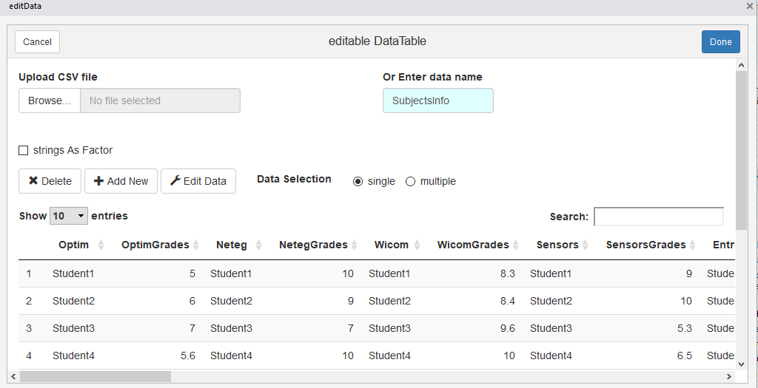

**Fig. 5.1** Edit datasets -library (editData)-

The “editData” library is not the only way to edit the datasets that are imported to the application. The R program gives the ability to edit the data tables directly from the Dashboard page from the web server though the command “editable = True”.

This command is giving the ability to the user to change the information on the data table only by double clicking on it. This technique is available when the command is on the server output part of the code.

The below figure is giving an example of the “editable = True” command.

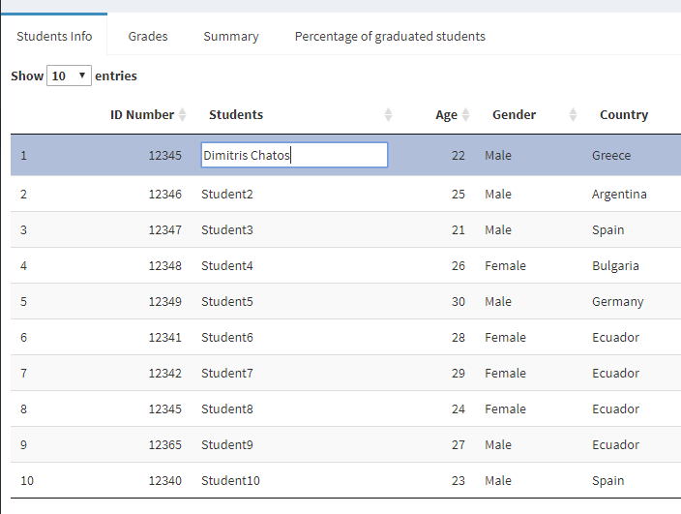

**Fig. 5.2** Edit datasets -command (editable = True)-

## 5.2 Maintenance of the Dashboard

The maintenance of the Dashboard is the last step that the user or the programmer need to do for keeping the MASTEAM Dashboard updated for future uses.

To maintain the datasets the user just need to update the dataset CSV files every six-month or every year when the new academically year will start and to edit new the new datasets or when they want to manipulate the already existed datasets when that is needed. The procedure is the same like was been explained on **5.1.2 Datasets edit and maintenance** subchapter.

The maintenance of the R application is the same, the user need to upgrade all the libraries when is needed for new libraries versions and for better visualization results.

All the new datasets that the user can import to the program can be visualised if they are following the same type and structure as the datasets that has been explained here on the subchapter ***3.1 Creation of the datasets on CSV format***.

# CONCLUSION

|  |  |
| --- | --- |
|  |  |